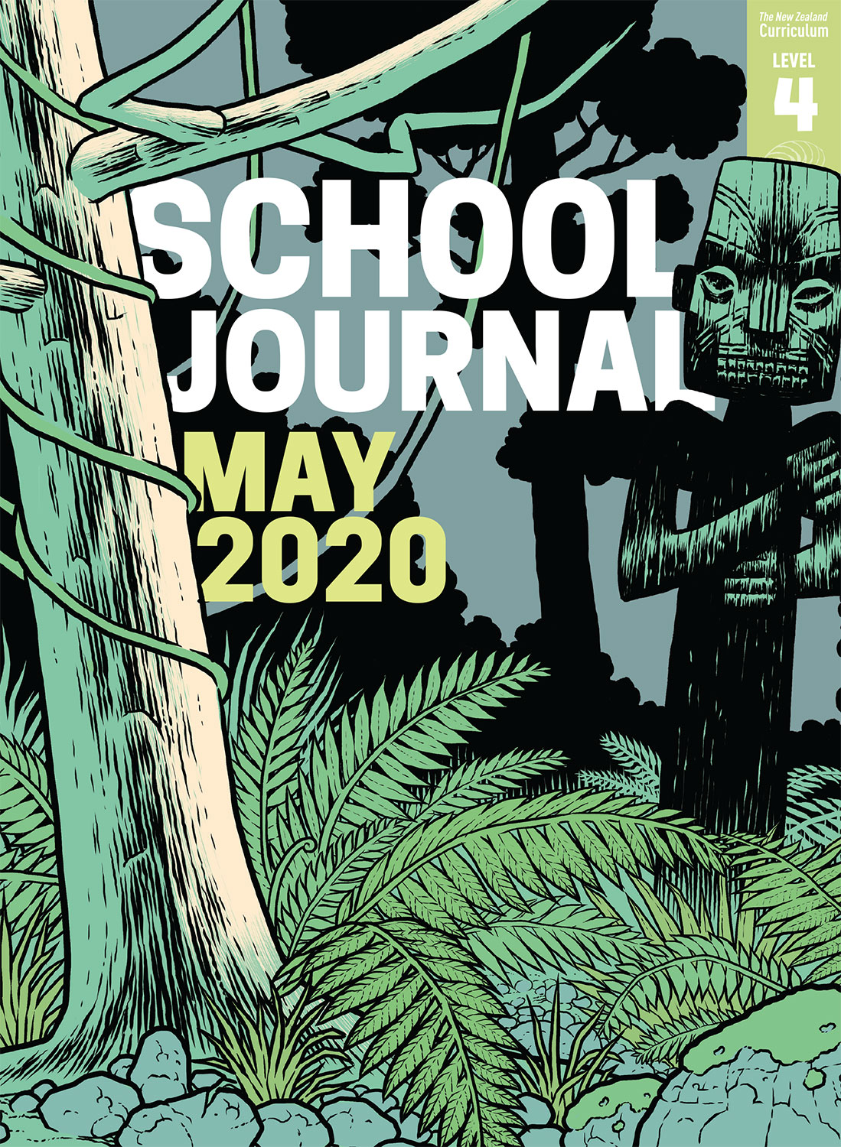

School Journal

Level 4, May 2020

**Year 7**

# The Musician

by Sarah Penwarden

The[Learning Progression Framework](https://curriculumprogresstools.education.govt.nz/lpf-tool/)s describe significant signposts in reading and writing as students develop and apply their literacy knowledge and skills with increasing expertise from school entry to the end of year 10.

## Overview

This family story captures the experience of forming a new relationship and how circumstances that are outside our control can end relationships. Equally, it’s about how families change – and especially about young people becoming aware of their parents as people with separate lives and with their own needs.

A PDF of the text is available at [www.schooljournal.tki.org.nz](http://www.schooljournal.tki.org.nz)

## Themes

* Family relationships
* Change
* Loss and resilience
* Empathy

## Related texts

“**The Weird Zone**” SJ L3 Nov 2019 | “**Little Fisherman**” SJ L3 Nov 2018

## Strengthening reading behaviours (what to notice)

|  |  |
| --- | --- |
| Text structure and features | Requiring students to: |
| * Metaphor and other figurative or connotative language * An odd, double negative construction in the first sentence and several pronoun references in the rest of the paragraph * Some incomplete sentences * The strong clear voice of the main protagonist | * use their prior knowledge of spoken language and text features to interpret the intended meaning * work out the relationships between the main characters and predict what will happen * identify the colloquial nature of the conversation and track the story’s progression * identify the main character’s perspective and understand the complexity of the situation for the two sisters. |

|  |  |
| --- | --- |
| Vocabulary | |
| Possibly unfamiliar words and phrases | wispy, gig, dhal, falafel, hippie, ear gauging, hipster, algebra, vegan, winced, riff, sceptical |
| Incomplete sentences | Drawing horses. ; Helping Dad with the ute. |
| Metaphor and other figurative or connotative language | bowled straight on in, Jed could nail American accents, caught the drift |

|  |
| --- |
| Helpful prior knowledge (pre-reading and introducing the text) |
| * Parents are also individuals with independent identities and their own needs. * Changing relationships between individuals can have an effect on the thoughts and feelings of those around them. |

## Possible reading and writing purposes

* Find out who the musician is and his impact on a close-knit family
* Compare the two sisters’ perspectives about the addition to their household
* Analyse the complexities that arise when relationships don’t work out in families

See *Effective Literacy Practice in Years 5–8* for information about teaching comprehension strategies ([Teaching comprehension](http://literacyonline.tki.org.nz/Literacy-Online/Planning-for-my-students-needs/Effective-Literacy-Practice-Years-5-8/Teaching-comprehension)) and for suggestions on using this text with your students ([Approaches to teaching reading](http://literacyonline.tki.org.nz/Literacy-Online/Planning-for-my-students-needs/Effective-Literacy-Practice-Years-5-8/Approaches-to-teaching-reading)).

## Possible curriculum contexts

This text has links to level 4 of the New Zealand Curriculum in:[**ENGLISH**](http://nzcurriculum.tki.org.nz/The-New-Zealand-Curriculum/English)[**HEALTH AND PHYSICAL EDUCATION**](http://nzcurriculum.tki.org.nz/The-New-Zealand-Curriculum/Health-and-physical-education)

## Understanding progress

The following aspects of progress are taken from the [Learning Progression Framework](https://curriculumprogresstools.education.govt.nz/lpf-tool/)s and relate to the specific learning tasks below. See the LPFs for more about how students develop expertise and make progress in these aspects:

* Reading for literary experience
* Making sense of text: reading critically
* Using writing to think and organise for learning
* Writing meaningful text: using knowledge of text structure and features.

## Strengthening understanding through reading and writing

The *School Journal* provides rich texts that can be returned to many times. The following suggestions are based on the premise that rereading the text is a fundamental part of developing students’ understanding and reading skills. **Select from and adapt** them, according to your students’ strengths, needs, and experiences.   
Note: Most of these activities lend themselves to students working in pairs or small groups.

* Have the students profile Jed and one other character in the story. They could organise their information visually and include quotes from the text.  They could use Google Slides and add an image of Jed, text boxes, and speech bubbles. Ask them to reflect, orally or in writing, on why the author might have included so much detail about Jed and what effect this had on how they felt about him. When looking for information about the characters, some English language learners might find that pronouns make the task difficult. Support these students by having them identify the reference chains. Take a section of text and ask them to identify and underline the nouns referring to a character (Mum, Jed, Sissy, Kayla, Dad, man, boyfriend). Then have them draw circles around all the pronouns and add arrows to link each pronoun with the person to whom it refers.
* Compare the reactions of Kayla and Sissy to Jed being the new boyfriend, him moving in, and then to him moving out. Do they think there is any change in the voice of the story? They could add how they might react to each situation and include reasons.
* Have the students write a dialogue between two characters, focusing on something that was unsaid, for example, what Kayla might have said to Jed about his departure, what else Sissy might have said to Dad, or what Mum might have said at the end of the story.  The students could create a comic strip in Google Slides to do this.
* Have the students use a PMI chart to analyse the impact of Mum’s relationship with Jed. They might organise the information into before, during, and after. They could also include a summarising statement to give their opinion on what they think about the changes in this family.
* Explore the author’s style of writing. Find examples of some of the different text features, such as the metaphors, connotative language, colloquialisms, short sentences, incomplete sentences, and the double negative at the start. Discuss the overall effect these have and whether the students enjoyed them.
* Identify any interesting or challenging vocabulary, for example, the difference between hippie and hipster, the food, the generational words, or words with multiple meanings, such as “nailed”, “drift”, “bowled”. Discuss why the author has used them.
* Have the students write a recount of their own experience of getting to know a new family member or describe a time when their family’s circumstances changed, using some of the text and language features from this story.
* Raise powerful questions using the **Powering up questions** template provided. Review different types of questions, discussing how there is a need for all types depending on the desired result. Together model some 5WH questions, finding the information in the story to answer them. Explore the effect of adding “should”, “could”, “would”, “will”, “might”, or “can” to one of these. Discuss how answers might require inference or personal opinion. In pairs, the students could use the question starters to make up a question and answer it. Questions might include: “Why were the girls wary of Jed to begin with?”, “How could a new person be introduced into a family?”. Try playing Hot-seat with the students taking turns being a character and responding to questions from the group.
* For more ideas and strategies to support English language learners, see [ESOL Online](https://esolonline.tki.org.nz/).

“The Musician” Powering up questions

|  |  |  |
| --- | --- | --- |
| Who? | What? | When? |
| Where? | Why? | How? |
|  |  |  |
| Should | Could | Would |
| Will | Might | Can |